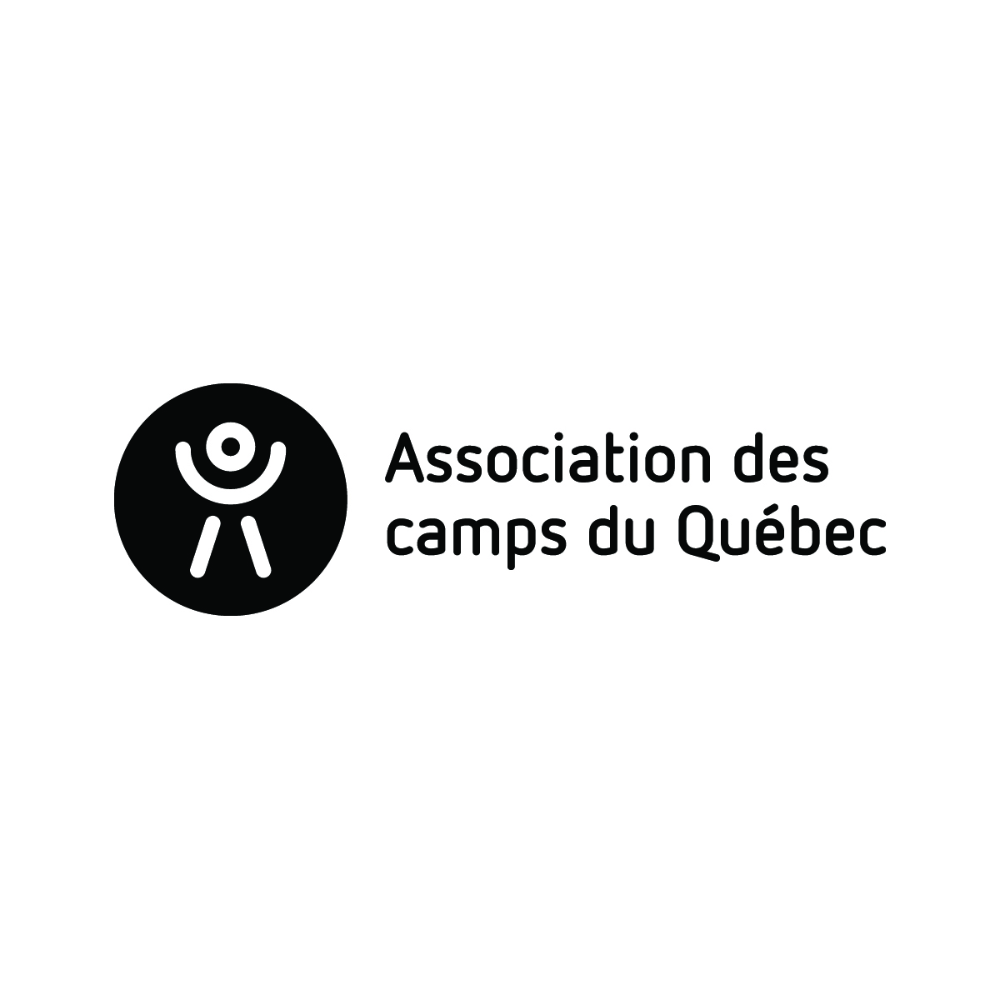

Complete and return ONLY if one or more major changes have taken place. Thank you!

In compliance with the Membership and Certification Policy of the Association des camps du Québec or with the “Cadre de reference pour les camps de jour municipaux”, Camp _________________________ hereby declares the following:

- List of major changes that took place during the year:

New owner
- Name(s): _________________________________________________________________
- Telephone(s): 1) __________________________ 2) ___________________________
- Email: _________________________________________________________________

New camp director (* Append resume as per the terms of standards)
- Name(s): _________________________________________________________________
- Telephone(s): 1) __________________________ 2) ___________________________
- Email: _________________________________________________________________

New location or additional new site (Add appendix if more than one site)
- Name of site: _________________________________________________________________
- Complete contact information: ____________________________________________________
_____________________________________________________
_____________________________________________________

New programs: Specify site where applicable:
Resident camp _____________________________________
Day camp _____________________________________
Municipal Day camp _____________________________________
Nature class _____________________________________
Group program _____________________________________
Family camp _____________________________________
Counsellor-in-training (CIT) _____________________________________

- Other changes: (program or site closure, general contact information, etc.):
__________________________________________________________________________________________________________________________________________________________________________________________
_______________________________________ _______________________________________
Name of signatory Occupation within the camp

_______________________________________ _______________________________________
Signature Date

Please return this form to us as soon as possible, but by May 1st, 2024 at the latest.
Send to info@campsquebec.com

